

5CS021 – Numerical Methods and Concurrency

**LAB REPORT – Week1**

**Attempt all questions**

1. Write a program to find the sum of numbers from 1 to 10.

1. Write a program to find the factorial of a number.

1. Write a program to print out all triangular numbers from 1 up to nth term.

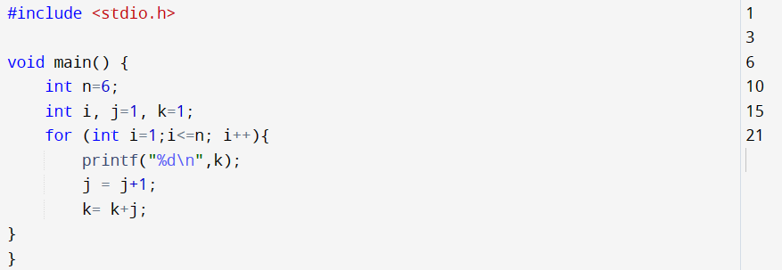

1. Write a program to input a character from the user and print it in lowercase. If the character is in uppercase then you have to change it in lowercase and if it is in lowercase then you have to print as it is.

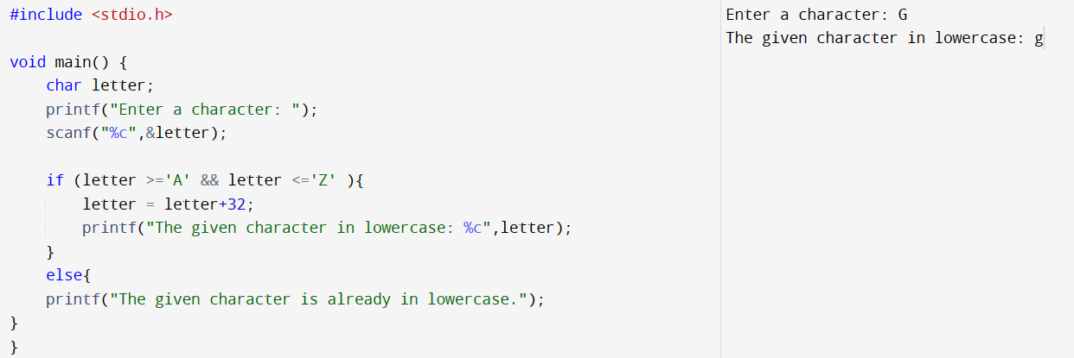

1. Make changes in the program of Question Number 4. Ask characters from the user until an enter key is pressed.

Hint: The ASCII Value of Enter key is 13.

1. Print the following pattern using nested loop:

A

* 1. B
  2. C C
  3. D D D
  4. E E E E

